Chapter 5, Solution 5.

+
-
Av_{d}
-
+
v_{i}
I
R_{in}
R₀
-

v_{d}

+

+
v₀
-

-v_{i} + Av_{d} + (R_{i} + R₀) I = 0 (1)

But v_{d} = R_{i}I,

-v_{i} + (R_{i} + R₀ + R_{i}A) I = 0

I = 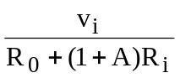 (2)

-Av_{d} - R₀I + v₀ = 0

v₀ = Av_{d} + R₀I = (R₀ + R_{i}A)I = 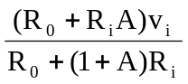
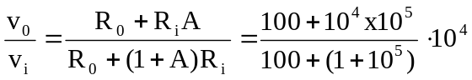

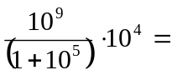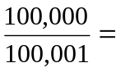 0.9999990

